Queue

What is a Queue?
# Source: AI Source: Provided by: [Data Path: Persons Table -> ID Column: 1, Name_En Column: Motasem Essam] -> From: [Chatgpt (GPT‑5 Mini)] on [12/10/2025]
- A linear data structure that follows FIFO (First In, First Out) principle.
- The first element added is the first one to be removed.
- Used for scheduling tasks, handling requests, and buffering data.

Key Characteristics
# Source: AI Source: Provided by: [Data Path: Persons Table -> ID Column: 1, Name_En Column: Motasem Essam] -> From: [Chatgpt (GPT‑5 Mini)] on [12/10/2025]
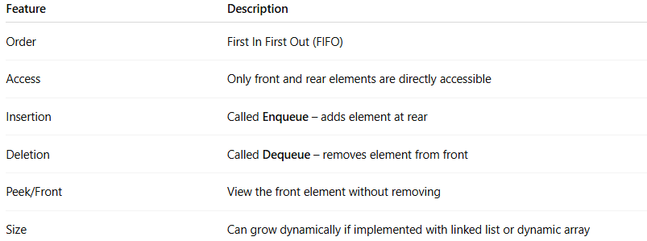
Feature | Description
Order | First In First Out (FIFO)
Access | Only front and rear elements are directly accessible
Insertion | Called Enqueue – adds element at rear
Deletion | Called Dequeue – removes element from front
Peek/Front | View the front element without removing
Size | Can grow dynamically if implemented with linked list or dynamic array

Types of Queue
# Source: AI Source: Provided by: [Data Path: Persons Table -> ID Column: 1, Name_En Column: Motasem Essam] -> From: [Chatgpt (GPT‑5 Mini)] on [12/10/2025]
- Simple / Linear Queue
  - Queue implemented using a linear array.
  - Fixed size unless dynamically resized.
  - Front moves forward after each dequeue, may cause unused spaces.
  - Example:
Front -> 10 20 30 <- Rear
- Circular Queue
  - Rear wraps around to the beginning when space is available.
  - Solves the problem of unused spaces in linear queue.
  - Example:
Rear -> 30 10 20 <- Front
- Priority Queue
  - Each element has a priority.
  - Element with highest priority is dequeued first, not necessarily FIFO.
  - Example:
[Priority 3: 40] [Priority 2: 20] [Priority 1: 10]
- Deque (Double-Ended Queue)
  - Insertion and deletion possible from both ends.
  - Combines features of stack and queue.
  - Example:
Front <-> 10 <-> 20 <-> 30 <-> Rear

Summary Table of Queue Types
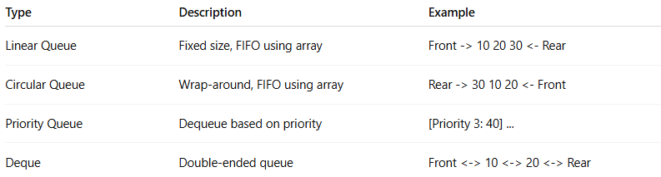
Type | Description | Example
Linear Queue | Fixed size, FIFO using array | Front -> 10 20 30 <- Rear
Circular Queue | Wrap-around, FIFO using array | Rear -> 30 10 20 <- Front
Priority Queue | Dequeue based on priority | [Priority 3: 40] ...
Deque | Double-ended queue | Front <-> 10 <-> 20 <-> Rear

Example of a Queue
# Source: AI Source: Provided by: [Data Path: Persons Table -> ID Column: 1, Name_En Column: Motasem Essam] -> From: [Chatgpt (GPT‑5 Mini)] on [12/10/2025]
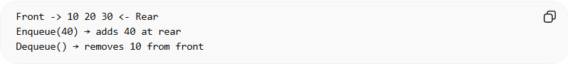
Front -> 10 20 30 <- Rear
Enqueue(40) → adds 40 at rear
Dequeue() → removes 10 from front

Common Operations on Queue

1. Enqueue (Adding an Element)
# Source: AI Source: Provided by: [Data Path: Persons Table -> ID Column: 1, Name_En Column: Motasem Essam] -> From: [Chatgpt (GPT‑5 Mini)] on [12/10/2025]
Definition:
- Adding a new element at the rear of the queue.
- Follows FIFO principle.
Example Queue (before enqueue):
Front -> 10 20 30 <- Rear
Enqueue 40:
Front -> 10 20 30 40 <- Rear
Example in C (Array-Based Queue):
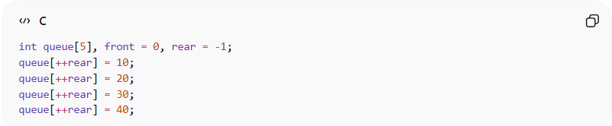
int queue[5], front = 0, rear = -1;
queue[++rear] = 10;
queue[++rear] = 20;
queue[++rear] = 30;
queue[++rear] = 40;
Enqueue Time Complexity:
- Time Complexity: O(1)
- Reason: Element is always added at the rear; no traversal required.

2. Dequeue (Removing an Element)
# Source: AI Source: Provided by: [Data Path: Persons Table -> ID Column: 1, Name_En Column: Motasem Essam] -> From: [Chatgpt (GPT‑5 Mini)] on [12/10/2025]
Definition:
- Removing the element from the front of the queue.
Example Queue (before dequeue):
Front -> 10 20 30 40 <- Rear
Dequeue operation removes 10:
Front -> 20 30 40 <- Rear
Example in C:
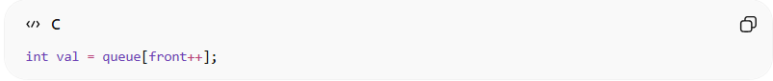
int val = queue[front++];
Dequeue Time Complexity:
- Time Complexity: O(1)
- Reason: Element is always removed from the front; no traversal needed.

3. Peek / Front (Reading the Front Element)
# Source: AI Source: Provided by: [Data Path: Persons Table -> ID Column: 1, Name_En Column: Motasem Essam] -> From: [Chatgpt (GPT‑5 Mini)] on [12/10/2025]
Definition:
- Retrieves the value of the front element without removing it.
Example Queue:
Front -> 20 30 40 <- Rear
Peek → returns 20, queue remains unchanged.
Example in C:
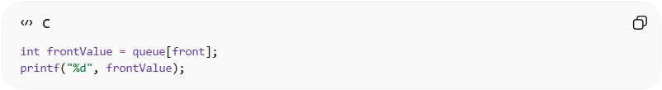
int frontValue = queue[front];
printf("%d", frontValue);
Peek Time Complexity:
- Time Complexity: O(1)
- Reason: The front element is directly accessible using the front index; no traversal is needed.

4. Traversal (Visiting All Elements)
# Source: AI Source: Provided by: [Data Path: Persons Table -> ID Column: 1, Name_En Column: Motasem Essam] -> From: [Chatgpt (GPT‑5 Mini)] on [12/10/2025]
Definition:
- Visiting each element in the queue from front to rear.
Example Queue:
Front -> 20 30 40 <- Rear
Traversal prints:
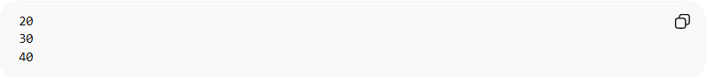
20
30
40
Example in C:
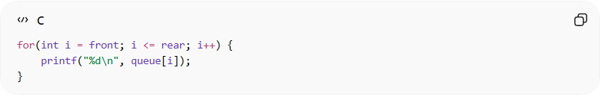
for(int i = front; i <= rear; i++) {
printf("%d\n", queue[i]);
}
Traversal Time Complexity:
- Time Complexity: O(n)
- Reason: Every element must be visited one by one from front to rear.

5. Searching (Finding an Element)
# Source: AI Source: Provided by: [Data Path: Persons Table -> ID Column: 1, Name_En Column: Motasem Essam] -> From: [Chatgpt (GPT‑5 Mini)] on [12/10/2025]
Definition:
- Finding the position of a specific value in the queue.
- Search starts from front.
Example Queue:
Front -> 20 30 40 <- Rear
Search for 30 → position 1 from front.
Example in C:
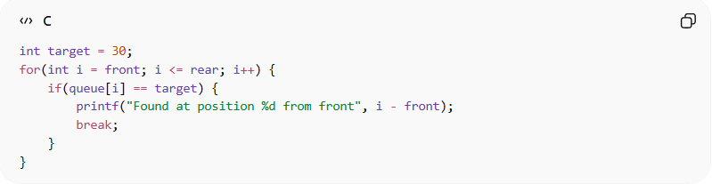
int target = 30;
for(int i = front; i <= rear; i++) {
if(queue[i] == target) {
printf("Found at position %d from front", i - front);
break;
}
}
Search Time Complexity:
- Time Complexity: O(n)
- Reason: Each element must be checked sequentially until the target value is found.

Summary of Queue Operations
# Source: AI Source: Provided by: [Data Path: Persons Table -> ID Column: 1, Name_En Column: Motasem Essam] -> From: [Chatgpt (GPT‑5 Mini)] on [12/10/2025]
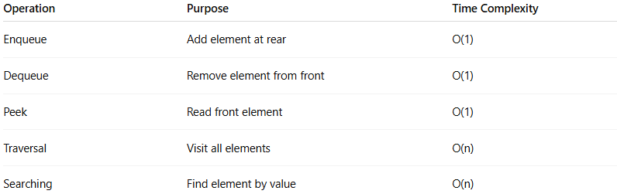
Operation | Purpose | Time Complexity
Enqueue | Add element at rear | O(1)
Dequeue | Remove element from front | O(1)
Peek | Read front element | O(1)
Traversal | Visit all elements | O(n)
Searching | Find element by value | O(n)

Example in C (Array-Based Queue)
# Source: AI Source: Provided by: [Data Path: Persons Table -> ID Column: 1, Name_En Column: Motasem Essam] -> From: [Chatgpt (GPT‑5 Mini)] on [12/10/2025]
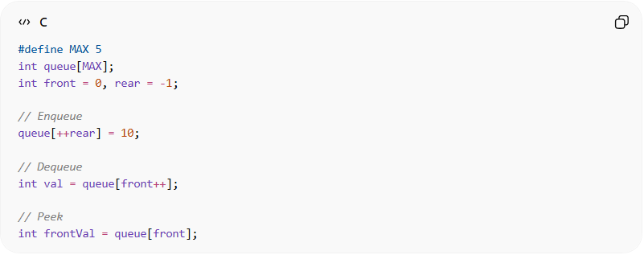
#define MAX 5
int queue[MAX];
int front = 0, rear = -1;

// Enqueue
queue[++rear] = 10;

// Dequeue
int val = queue[front++];

// Peek
int frontVal = queue[front];

Real-World Examples
# Source: AI Source: Provided by: [Data Path: Persons Table -> ID Column: 1, Name_En Column: Motasem Essam] -> From: [Chatgpt (GPT‑5 Mini)] on [12/10/2025]
- Print queue in offices
- CPU task scheduling
- Call center customer requests
- Keyboard input buffering

Advantages
# Source: AI Source: Provided by: [Data Path: Persons Table -> ID Column: 1, Name_En Column: Motasem Essam] -> From: [Chatgpt (GPT‑5 Mini)] on [12/10/2025]
- Simple and easy to implement
- Fast insertion and deletion at ends (O(1))
- Maintains order of processing (FIFO)

Disadvantages
# Source: AI Source: Provided by: [Data Path: Persons Table -> ID Column: 1, Name_En Column: Motasem Essam] -> From: [Chatgpt (GPT‑5 Mini)] on [12/10/2025]
- Only front and rear accessible directly
- Fixed size in array-based implementation
- Searching and traversal can be slow (O(n))

